Source Data Mapping Approach to CDMV5.4

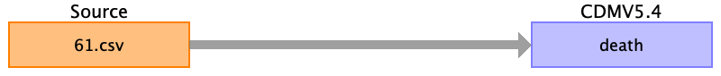

Table name: person

Table name: observation_period

Table name: visit_occurrence

Table name: visit_detail

Table name: condition_occurrence

Table name: drug_exposure

Table name: procedure_occurrence

Table name: device_exposure

Table name: measurement

Table name: observation

Table name: death

Reading from 61.csv

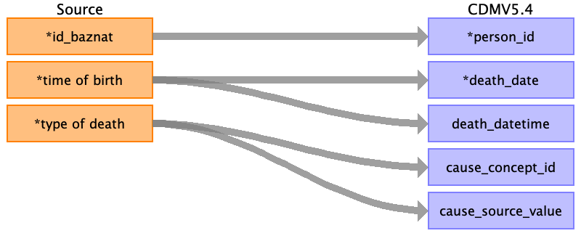

|  |  |  |  |
| --- | --- | --- | --- |
| Destination Field | Source Field | Logic | Comment |
| person_id | ﻿id_baznat |  |  |
| death_date | time of birth |  | Only date DD/MM/YYYY |
| death_datetime | time of birth |  | Date and time - DD/MM/YYYY HH:MM:SS |
| death_type_concept_id |  |  | EHR_concept_id 32817 |
| cause_concept_id | type of death | INTRAUTERINE_FETAL_DEATH = 4129846  FETAL_DEATH_DUE_TO_TERMINATION_OF_PREGNANCY = 436228  INTRAPARTUM_FETAL_DEATH = 4028785  EARLY_NEONATAL_DEATH = 4307303  SELECTIVE_FETECIDE = 4045947  INTRAUTERINE_DEATH_OF_ONE_TWIN = 4028786 | Intrauterine fetal death  concept id - 4129846  Fetal death due to termination of pregnancy  concept id - 436228  Intrapartum Fetal Death  concept id - 4028785  Early neonatal death  concept id - 4307303  Selective Fetecide  concept id - 4045947  Intrauterine death of one twin  concept id - 4028786 |
| cause_source_value | type of death | AS IS | Not use in this field. |
| cause_source_concept_id |  |  | Not use in this field. |

Table name: note

Table name: note_nlp

Table name: specimen

Table name: fact_relationship

Table name: location

Table name: care_site

Table name: provider

Table name: payer_plan_period

Table name: cost

Table name: drug_era

Table name: dose_era

Table name: condition_era

Table name: episode

Table name: episode_event

Table name: metadata

Table name: cdm_source

Table name: cohort

Table name: cohort_definition

Appendix: source tables

Table: 61.csv

|  |  |  |  |
| --- | --- | --- | --- |
| Field | Type | Most freq. value | Comment |
| ﻿id_baznat | INT |  |  |
| event_baznat | INT |  |  |
| infant numer | INT |  |  |
| time of birth | INT |  |  |
| weight | INT |  |  |
| presentation | INT |  |  |
| cham_hosp_entry_date | INT |  |  |
| cham_hosp_exit_date | INT |  |  |
| age_category | INT |  |  |
| apgar 1 - sum of values | INT |  |  |
| apgar 1 - pulse | INT |  |  |
| apgar 1 - breathing | INT |  |  |
| apgar 1 - color | INT |  |  |
| apgar 1 - tone | INT |  |  |
| apgar 1 - response | INT |  |  |
| apgar 5 - amount of values | INT |  |  |
| apgar 5 - pulse | INT |  |  |
| apgar 5 - breathing | INT |  |  |
| apgar 5 - color | INT |  |  |
| apgar 5 - tone | INT |  |  |
| apgar 5 - response | INT |  |  |
| apgar 10 - amount of values | INT |  |  |
| apgar 10 - pulse | INT |  |  |
| apgar 10 - breathing | INT |  |  |
| apgar 10 - color | INT |  |  |
| apgar 10 - tone | INT |  |  |
| apgar 10 - response | INT |  |  |
| mode of birth | INT |  |  |
| stillbirth | INT |  |  |
| type of death | INT |  |  |
| cause of death death - comments | INT |  |  |
| a number will discuss giving birth | INT |  |  |
| umbilical cord with 3 blood vessels | INT |  |  |
| blood was taken | INT |  |  |
| through rescue | INT |  |  |
| birth notice | INT |  |  |
| sex | INT |  |  |
| record_date | INT |  |  |